**Operating Systems and You – Becoming a Power User**

CAPACITI, BRAAMFONTEIN

Nokuthula Ngcongo

2025

## **Step 1: Create a New User**

**Command used:** sudo adduser studentuser

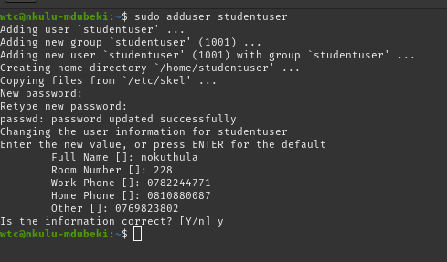

**Explanation:**

I created a new user called “studentuser” using the adduser command. I set a password and added optional personal details like full name and phone numbers. This allows a new account to be used for testing file permissions and other tasks.

## **Step 2: Switch to the New User**

**Command used:** su - studentuser

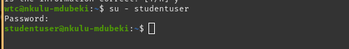

**Explanation:**

I switched to the new user account to verify it works correctly. This confirms the account is active and can be used to perform user-level tasks.

## **Step 3: Manage File Permissions**

### **3.1 Create a Test Folder**

**Command:** mkdir testfolder, ls -ld testfolder

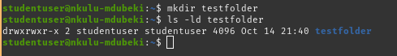

**Explanation:**

I created a folder called testfolder in the new user’s home directory. Using ls -ld, I checked the folder’s owner and default permissions.

### **3.2 Change Folder Permissions**

**Command:** chmod 700 testfolder, ls -ld testfolder

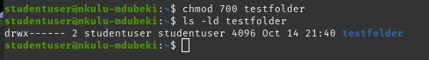

**Explanation:**

I used chmod 700 to restrict access to the folder so that only the owner can read, write, or execute. Other users have no access.

## **Step 4: Install Software Using apt**

### **4.1 Update Package List**

**Command:** sudo apt-get update  
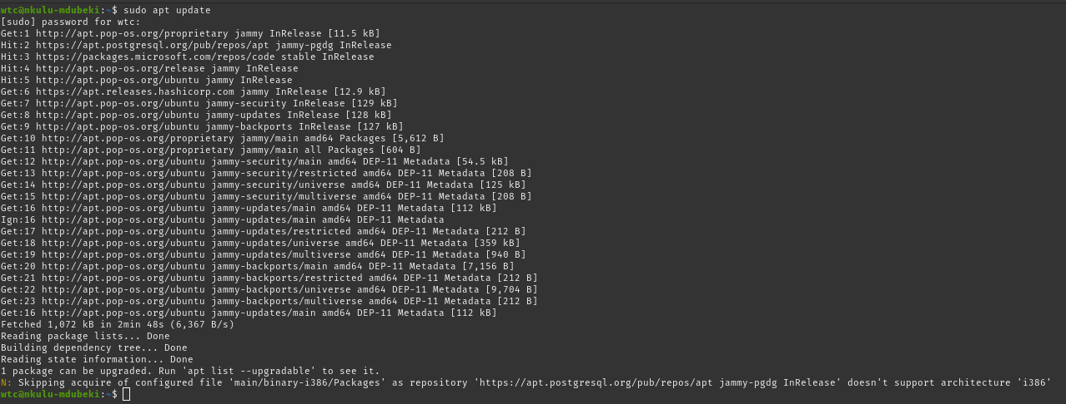

**Explanation:**

I updated the package list with sudo apt-get update to ensure my system knows the latest versions of available software packages.

### **Install a Software Package**

**Command:** sudo apt-get install vim -y  
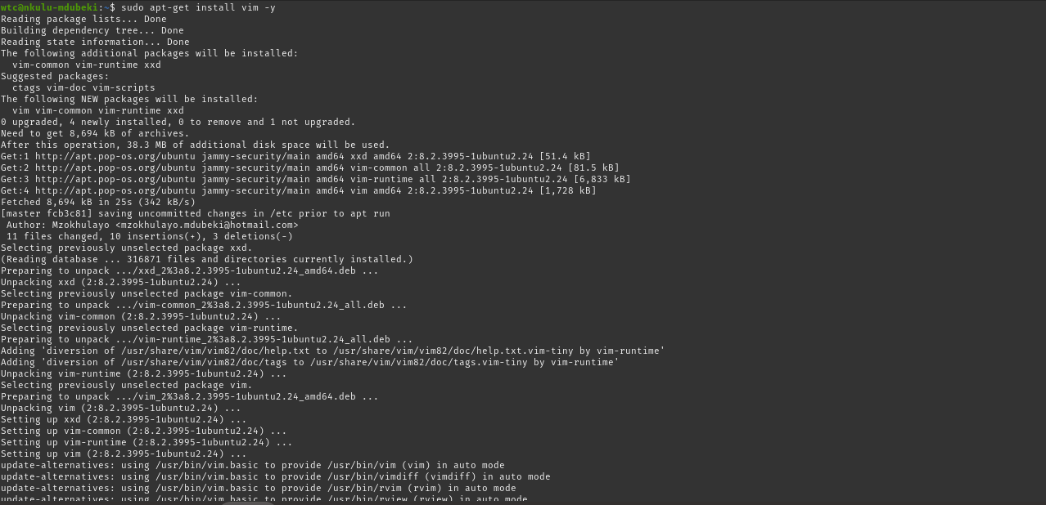

**Explanation:**

I installed the text editor Vim using sudo apt-get install vim -y. The -y flag automatically confirms installation prompts.

### **Verify Installation**

**Command:** vim --version



**Explanation:**

I verified the installation by checking the Vim version. This confirms the software was installed successfully.

## **Conclusion**

In this practical task, I successfully created a new user, managed folder permissions, and installed software using the Linux command line. I learned how to safely manage users, control access to files, and use apt to handle software installations. These skills are essential for effective Linux system administration.